A multi-PURPOSE and multi-NETWORK compliance management software package

Product Overview | All aspects - from installation to implementation to deployment - are designed to be simple and easy, yet extremely powerful.  The multi-purpose secret is in the clever system and module design. The system focuses on compliance and management tools with four complimentary modules that can be adapted to suit any business requirement.  The multi-network design means this product can be deployed over the web, LAN or WAN seamlessly, giving total flexibility and freedom like never before. Now everybody can work in a network suitable to their level of responsibility.  Paradigm 3 solves literally any compliance management issue and allows you to continually build, improve, modify and add to your compliance system as your organisation compliance needs mature.  - Administrators can work from anywhere  - Publish documents directly to Microsoft SharePoint or to your intranet  - Users can work directly in the application over a LAN or WAN or via the web.  - Customise your intranet with hot links for raising commonly used forms and viewing documents.
Functionality | Version control in all modules in accordance with international ISO standards.  Hosts Microsoft Word and Excel (2003 and above) to control header and footer key compliance related information like version number, version dates, item numbers, authorizer, etc. so that the documentation viewed on screen or printed is automatically updated. (can also control any other applications)  Advanced cross referencing and navigation system called Para-Link® across all modules. Para-Links® hold even after items are renamed or moved. Navigate to other location using Show Me or Go There Buttons.  Closed loop notification system called Action Items that automatically trigger as events occur or schedule dates are reached. Each user is continually updated with an Action Item do list. Actions require acknowledgement and are retained as evidence. (Example, Actions to review, approve, read, records or audits to be done.)  Turn actions from minutes of meetings, reports, audit findings into Action Items and monitor progress.  Compliance evidence can be electronic Word or Excel forms in the document module or database forms use the records and Improvement modules

Design features | By using Smart Client architecture, the application has rich functionality at the desktop in any network mode.  Unique user interface to the software called Work Management Processor®. This interface guides the user on key information relevant to the position they hold - Action Items, Last Items Modified and a display of what is important to them.  When a user receives Action Items, they simply use the Show Me button and the software finds the associated item to view and update. For more advanced processing, the Go There button jumps to the exact spot in the software.  Define roles names to match your business culture. The software then drives the system against the defined roles.  Powerful unbreakable cross referencing system in all modules.  Automated organisational change control. As job titles change, document content is automatically updated.  Customisable process flow development tool called Event Manager. Build the Action Item message and process flow based on the roles within the organisation.  Paradigm 3 uses reverse metadata population. Instead of adding lengthy metadata during importation, Paradigm 3 applies the metadata from folder defaults making importation quicker, more accurate and less frustrating.
What can P3 do for you?  Manage these compliance issues | The following list outlines some of the general processes Paradigm 3 can be used for:  - Schedule and manage business and safety risk  - Continual improvement programs  - Effectively manage preventive & corrective action (CA) (CAPA, NCR, CAR)  - Control database and electronic forms to International document control standards  - Schedule and record equipment maintenance  - Manage policies, manuals, procedures and Instructions (SOP’s, work instructions)  - Schedule and record instrument calibration, internal/external audits and management reviews  - Co-ordinate product or service non conformity  - Track objectives and targets  - Manage and distribute planning and project documentation  - Competences awareness and training

Documents  Module   | This module controls all the company management system documentation from policies, procedures, instructions etc., as well as related evidence and records which are all written in Microsoft Word, Excel or other applications.  This is the module used for control of documents. Paradigm 3 hosts and controls the application by managing essential issues such as electronic signature, versioning, security restrictions. Paradigm 3 lets you work directly with the original document and can automatically publish directly to Microsoft SharePoint or to your intranet to ensure that only the most current version is available.  Key Benefits:  - Define your own versioning roles and then assign roles to users, titles or departments.  - Develop your own header and footer template with key control of documentation insert fields that automatically update with each new version.  - Insert job titles, departments or role names directly into MS Word or Excel so that organisational title name changes are automatically updated through out each document.  - Configure the event notification system to suit your requirements. Paradigm 3 ‘s customisable built-in event management system allow administrators to design Action Item content as well as control the work flows. For example, when an item has been approved, who needs to know and what action do they need to take.  - Set reminder schedules for reviews or any other system related reminders.  - Extract text from minutes of meetings, reports, or audits and dump the text into a notification with a direct link back to the original document for a simple but effective corrective action system.
Records Module  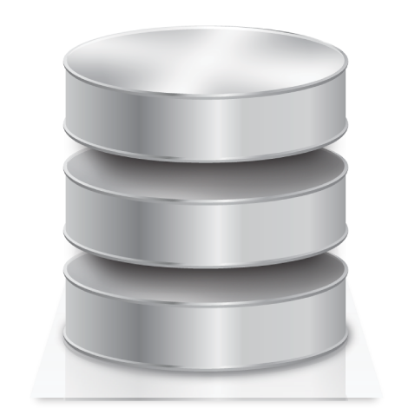 | Many forms or registers have advantages being maintained in database format rather than word processor or spreadsheets. The database designs can be from one to 15 pages long with the capability to link to external data, mandatory field control and perform calculations.  Example are:  Assets, Confined Space, Continuous improvement, Customer satisfaction, Customers, Electrical/Lifting equipment/ Oxygen/ Fire Extinguishers, Environmental Impact, Hazards, Hazardous Substances, International Standards, Legal, Licences/Certificates/Subscriptions, Material Safety Data Sheet, Personnel, Plant & Equipment, Quality Records, Sales leads and contacts, Software, Suppliers, Transport.  Key Benefits:  - Paradigm 3 is supplied with the above example styles which can be used as they are, modified or design your own from scratch.  - Set security and responsibility at folder level to control what everybody can or cannot do.  - This module also has version control capability for full audit traceability - Open, Completed and all Obsolete versions.  - Cross link the records to the management system documentation that define your management system using Para-Links®.

Improvement Module   | This module will usually involve management issues relating to improvement or corrective action disciplines. As such it incorporates a disciplined process flow methodology where each page must be completed by an assigned responsible person before the next page can be started.  Users are automatically notified as the form progresses through each stage. Completed stages are locked and a Progress Tracker tool summaries the activities from start to finish. The database designs can be up to 25 pages long with the capability to link to external data, mandatory field control and perform calculations.  Example are:-  Business and Safety Risk Assessments, Audit non conformance, Change control, Concern, Customer Complaint, Hazard control, Incident or Accident, Key Performance Indicator, Non conforming product, Non conforming service, Objectives, Preventative Action, Task management.  Key Benefits  - Paradigm 3 is supplied with the above example styles which can be used as they are, modified or design your own from scratch.  - Set security and responsibility at folder level to control what everybody can or cannot do.  - Assign responsibility for each page as defaults at folder level. As new items are raised and processed, users are automatically notified.  - Use the Progress Tracker to monitor progress and generate reports as required.  - This module also has version control capability for full audit traceability - Open, Completed and all Obsolete versions.  - Cross link the improvements to the management system documentation that define your management system using Para–Links®.
Training Module   | This module manages staff training from planning through to completion - maintain qualifications, licences, internal and external training activities. The added feature is Paradigm 3 can link training against management system documentation. The database designs can be up to 25 pages long, with the capability to link to external data, mandatory field control and perform calculations.  Key benefits  - Paradigm 3 is supplied with training records styles which can be used as they are, modified or design your own from scratch.  - Set security and responsibility at folder level to control what everybody can or cannot do.  - Automatically notify users when training is due.  - This module also has version control capability for full audit traceability - Open, Completed and all Obsolete versions  - Cross link the training to the management system documentation that define your management system using Para–Links®.

Action Item Module   | This module keeps everybody informed of their management system responsibilities and accountability by issuing notifications in the form of Action Items. In Paradigm 3 Action Items are not just a notification that can be ignored, they become a record that is retained in the system. Users must acknowledge actions and completed tasks are then permanently attached to the associated item as evidence that the task was done.  Action Items are triggered by setting Events that sit dormant until that trigger is reached. Administrators can configure the Events and construct the Action Item content. Triggers may be when a schedule date is reached or when a document is approved.  Key Benefits:  - Paradigm 3’s Action Item system the integral part of the management evidence of the management system. Action Items are issued, completed and retained in the software as evidence.  - Action Items have a direct link to the associated item by selecting a Show Me button. Users can then work directly with the item, complete the task at hand and then return to the Action Item.  - Action Items can force users to nominate a result in a customisable results list. Depending on the result they select, a corresponding escalated Action Item is triggered. The scope for configuring process work flows is endless and simple to implement.  - Action Items delegate and disperse the management system responsibilities and accountability throughout the organisation rather than placing the task on a selected few. Overall your system runs smoother and more efficiently.
Users Module  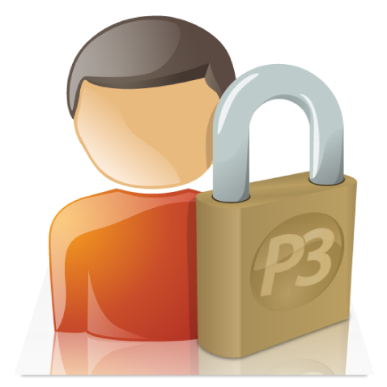 | The Users Module is the back-bone to the overall operating system of Paradigm 3, to manage roles, accountability and so that action items can be issued.  Key benefits:  - Define the organisational structure, divisions, departments and staff position titles.  - Load users (via domain name registry or manually) and match positions titles.  - Manage user names and passwords.  - Assign security levels and visibility for power and functional administrators.  - Due to the Smart Design, Paradigm 3 can have multiple administrators throughout the organisation looking after their own area of interest.  - The IT department need not be involved in the initial set up and on going maintenance.  - Changes are in ‘real time’ and each administrator security level and restricted visibility ensures they can only perform operations in assigned areas.
Technical Information | Paradigm 3 is a .NET application using smart client technology and optimized for SQL database.

